WEB-BASED SALES AND DEBT MANAGEMENT SYSTEM
(KIBANDA LEDGER)

KENNEDY BARAKA KABURU

A Research Project Submitted to the School of Science, Engineering and Technology in Partial Fulfilment of the Requirements for the award of Diploma in Information Technology,Kabarak University.

April, 2026

COPYRIGHT
© 2026
All Rights Reserved
No part of this project may be reproduced, stored in any retrieval system or transmitted in any form or by any means, electronic, mechanical, photocopying, and recording without prior written permission of the author or Kabarak University on that.
Sign: ________________________ Date: ________________________

DECLARATION AND APPROVAL
I declare that this work without any reasonable doubt has never been presented before to the Faculty of Information Technology or any other Institution. No part of this research document shall therefore be duplicated without prior consent.
Sign: ________________________ Date: ________________________
Student: Kennedy Baraka Kaburu
Reg No: DIT/N/2771/09/24

RECOMMENDATION
This research proposal entitled Web-Based Sales and Debt Management System “Kibanda Ledger” written by Kennedy Baraka Kaburu is presented to the School of Science, Engineering and Technology of Kabarak University. I have reviewed this project and recommended it will be accepted in partial fulfilment of the requirements for the Diploma in Information Technology.
Signature: ________________________ Date: ________________________

Mr. Elvine Saikwa,
School of Science, Engineering and Technology,
Department of Computer Science and Information Technology,
Kabarak University.

ACKNOWLEDGEMENT
I praise God for the gift of life, family, friends and provision without which I would not have made it this far in my academic pursuits. Indeed, the very ability to think, create and build is a gift for which I remain grateful.Many special thanks to our lecturers and supervisor Mr. Elvine Saikwa for their guidance and patience throughout my studies. Your wise counsel and input during my research has made this possible.
I also extend my sincere gratitude to fellow students and small business vendors in Nakuru whose feedback and day-to-day operational challenges inspired and shaped the design of this system.

DEDICATION
This piece of work is dedicated to my parents for their continuous support, guidance and advice through my life and education, and to every small business owner in Kenya whose resilience and entrepreneurial spirit inspired this project.

ABSTRACT
Small-scale traders and informal vendors in Kenya, commonly referred to as kibanda operators, face significant challenges in tracking daily sales, managing customer debts, and generating financial statements. The reliance on paper-based ledgers and manual record-keeping results in inaccuracies, loss of data, and difficulty in making informed business decisions.This research project presents the design and implementation of a Web-Based Sales and Debt Management System, branded as Kibanda Ledger. The system is a Python Flask web application that enables vendors to record sales transactions, manage customer debts, search and filter customer credit records, mark debts as settled, and generate downloadable PDF financial statements. The system was built using the Agile Software Development Methodology, with a SQLite relational database for persistent storage. The application features user authentication with hashed password security, a real-time dashboard displaying today's sales and total outstanding debts, a customer search functionality, and a WhatsApp quick-contact integration. System testing confirmed that all functional and non-functional requirements were met. The Kibanda Ledger system successfully addresses the problem of manual record-keeping among informal traders by providing a fast, secure, and easily accessible digital alternative that can be operated from any internet-connected device.
Keywords: Kibanda Ledger, Flask, Sales Management, Debt Tracking, SQLite, PDF Statement, Python, Web Application

TABLE OF CONTENTS
COPYRIGHT ii
DECLARATION AND APPROVAL iii
RECOMMENDATION iv
ACKNOWLEDGEMENT v
DEDICATION vi
LIST OF TABLES xii
LIST OF FIGURES xiii
CHAPTER ONE 1
INTRODUCTION 1
1.0 Background 1
1.1 Problem Statement 1
1.2 Purpose of Study 2
1.3 General Objective 2
1.3.1 Specific Objectives 2
1.4 Research Questions 2
1.5 Justification of the Study 3
1.6 Scope of the Study 3
1.7 Limitations of the Study 3
1.8 Assumptions of the Study 3
CHAPTER TWO 5
LITERATURE REVIEW 5
2.0 Introduction 5
2.1 Sales Management for SMEs in Kenya 5
2.1.1 Challenges Facing Small Traders in Record Keeping 5
2.2 Related Works 6
2.2.1 QuickBooks 6
2.2.2 Wave Accounting 6
2.2.3 Flare Ambulance App (Related Context) 6
2.3 General Gaps in Existing Systems 7
2.4 Conceptual Framework 7
CHAPTER THREE 9
RESEARCH METHODOLOGY 9
3.0 Introduction 9
3.1 System Development Methodology 9
3.1.1 Requirements Analysis 10
3.1.2 Design 10
3.1.3 Develop 10
3.1.4 Testing 10
3.1.5 Maintenance 11
3.1.6 Feedback 11
3.2 Functional Requirements 11
3.2.1 User Registration and Authentication 11
3.2.2 Recording Sales Transactions 11
3.2.3 Debt Management 11
3.2.4 Customer Search 11
3.2.5 Debt Settlement 12
3.2.6 Dashboard Display 12
3.2.7 PDF Statement Download 12
3.2.8 WhatsApp Integration 12
3.3 Non-Functional Requirements 12
3.4 Tools and Techniques 13
3.4.1 Python Flask 13
3.4.2 SQLite 13
3.4.5 fpdf 13
3.4.6 Werkzeug / Flask-Login 14
3.4.7 HTML / CSS 14
3.5 Milestones and Deliverables 14
3.5.1 Kibanda Ledger Web Application 14
3.5.2 Vendor Module 14
3.5.3 Administrator Module 14
3.5.4 User Manual 14
3.6 Data Collection Methods 14
3.6.1 Primary Data Collection 15
3.6.2 Secondary Data Collection 15
3.7 Data Flow Diagram 15
3.7.1 Context Diagram — Level 0 15
SYSTEM ANALYSIS, IMPLEMENTATION AND DESIGN 16
4.1 Analysis Diagrams 16
4.1.1 Use Case Diagram 16
4.1.2 Sequence Diagram 17
4.1.3 System Sequence Diagram 18
4.1.4 Class Diagram 18
4.1.5 Activity Diagram 19
4.1.6 State Chart Diagram 19
4.1.7 Flowchart 20
4.2 Design Diagrams 21
4.2.1 Database Schema 21
4.2.2 Administrator Module 22
4.2.3 Vendor Module (Dashboard) 22
4.2.4 Verification and Registration Module 23
4.3 Description of Implementation 24
4.3.1 Hardware Specifications 24
Table 3 Hardware Specifications 24
4.3.2 Software Specifications 24
4.4 Description of Testing and Results 25
4.4.1 System Testing 25
4.4.2 25
Functional Testing Data and Results 25
4.4.3 26
Non-Functional Requirements Testing 26
4.4.4 Description of Results 27
CHAPTER FIVE 29
CONCLUSION AND RECOMMENDATION 29
5.0 Introduction 29
5.1 Conclusion 29
5.2 Recommendation 29
5.3 Future Works 30

LIST OF TABLES
Table 1 Non-Functional Requirements 12
Table 2 Database Schema 21
Table 3 Hardware Specifications 24
Table 4 Software Specifications 24
Table 5 Functional Testing Data and Results 25
Table 6 Non-Functional Requirements Testing 27
LIST OF FIGURES

Figure 1 Conceptual Framework........................................................9
Figure 2 Agile Methodology Cycle...................................................10
Figure 3 DFD Context Diagram - Level 0.......................................15
Figure 4.1 Use Case Diagram...............................................................17
Figure 4.Sequence Diagram - Record Debt Flow.........................18
Figure 5 Activity Diagram...................................................................21
Figure 6 Flowchart..............................................................................23
Figure 7 Database Schema................................................................25
Figure 8 Dashboard (index.html)......................................................26
Figure 9 Login Page (login.html)......................................................26
Figure10 Registration Page (register.html)....................................27

LIST OF ABBREVIATIONS
API | Application Programming Interface
CSS | Cascading Style Sheets
DB | Database
DFD | Data Flow Diagram
Flask | Python Micro Web Framework
HTML | HyperText Markup Language
HTTP | HyperText Transfer Protocol
IT | Information Technology
JSON | JavaScript Object Notation
KES | Kenyan Shilling
PDF | Portable Document Format
PK | Primary Key
SME | Small and Medium Enterprise
SQL | Structured Query Language
SQLite | Self-Contained SQL Database Engine
UI | User Interface
URL | Uniform Resource Locator
WSGI | Web Server Gateway Interface

CHAPTER ONE

INTRODUCTION

1.0 Background
Kenya has a vibrant informal economy with millions of micro, small, and medium enterprises (MSMEs) operating in open-air markets, roadside kiosks, and informal trading centres commonly referred to as kibanda businesses. These traders form the backbone of Kenya's retail economy, dealing in fast-moving consumer goods, foodstuffs, airtime, hardware, and services. However, despite their economic importance, the majority of these traders rely on paper-based methods to manage their sales records and customer credit obligations.
The inadequacy of manual record-keeping systems frequently results in under-reporting of sales, untracked customer debts, financial losses, and inability to access credit from financial institutions. According to the Kenya National Bureau of Statistics, MSMEs contribute approximately 33% of the country's GDP and account for over 80% of total employment, yet only a small fraction of these businesses use digital tools for financial management.
The emergence of affordable internet access and mobile-friendly web technologies has opened new opportunities for digital solutions tailored for small traders. Web-based tools have demonstrated that technology adoption is feasible even among traders with limited formal education, provided the interface is simple and intuitive.
This project was motivated by the practical need observed among kibanda traders in Nakuru County who consistently struggled to remember customer debts, reconcile daily sales totals, and produce financial summaries for planning purposes. The Kibanda Ledger system was therefore designed as an accessible, mobile-friendly web application to address these core pain points through automation, digital record-keeping, and downloadable financial reporting.

1.1 Problem Statement
Small-scale traders and informal vendors in Kenya continue to rely on handwritten notebooks and oral agreements to track sales and credit extended to customers. This approach results in frequent data loss, disputes over amounts owed, inability to generate financial summaries, and time wasted on manual reconciliation at end of day. Furthermore, there is no systematic way to remind customers about outstanding debts, leading to bad debts accumulating over time. The absence of an affordable, simple-to-use digital record-keeping solution specifically designed for the Kenyan kibanda context represents a critical gap that this project seeks to address.

1.2 Purpose of Study
The purpose of this study is to design and implement a web-based system that enables small-scale traders to efficiently record sales transactions, track and manage customer debts, search and filter customer credit records, and generate downloadable PDF financial statements — all through a simple, secure interface accessible from any internet-connected device.

1.3 General Objective
To design and develop a web-based sales and debt management system that provides small-scale Kenyan traders with a fast, secure, and automated digital alternative to manual record-keeping.

1.3.1 Specific Objectives
- To determine the challenges faced by small-scale traders in managing sales records and customer debts using manual methods.
- To determine the requirements for designing a web-based application that provides automated sales tracking, debt management, and financial reporting for small-scale traders.
- To implement a web-based application with sales tracking, debt management, and PDF financial reporting capabilities for small-scale traders.

1.4 Research Questions
- What are the challenges faced by small-scale traders in managing sales records and customer debts using manual methods?
- How can a web-based application that provides automated sales tracking, debt management, and financial reporting be designed for small-scale traders?
- How can such a web-based application be implemented and tested to meet the functional and non-functional requirements of the target users?

1.5 Justification of the Study
The Kibanda Ledger system directly addresses a practical and widespread problem affecting millions of informal traders across Kenya. By replacing paper ledgers with a digital system, the project demonstrates that affordable web technologies — including Python Flask, SQLite, and the fpdf library — can be combined into a practical, deployable business tool. The study contributes to the growing body of research on ICT for Development (ICT4D) in sub-Saharan Africa and provides a replicable model for similar applications in the informal economy sector.

1.6 Scope of the Study
The scope of the Kibanda Ledger system covers the following functionality: user registration and secure login; recording and viewing of daily sales transactions; recording of customer debts with phone numbers; a searchable debt management interface; marking debts as settled; downloadable PDF financial statements; a real-time dashboard showing today's sales and total outstanding debts; and a WhatsApp quick-contact link for customer follow-up. The system is implemented as a web application accessible via a standard browser and requires an active internet connection.

1.7 Limitations of the Study
- Dependency on stable internet connectivity, which may not be consistently available in all kibanda locations.
- The system was developed and tested on a single local machine and has not yet been deployed to a cloud server.
- Resource constraints limited hardware procurement for extensive physical device testing.

1.8 Assumptions of the Study
The study assumed that target users own or have access to an Android or iOS smartphone or desktop computer with internet access. It was also assumed that users possess basic smartphone literacy sufficient to navigate a web-based application. It was further assumed that the hosting environment would maintain consistent uptime and that vendors would have access to a stable internet connection during business hours.

CHAPTER TWO

LITERATURE REVIEW

2.0 Introduction
This chapter examines the existing body of knowledge relevant to sales management systems, debt tracking applications, and the adoption of digital financial tools among small and medium enterprises in Kenya and sub-Saharan Africa. It also reviews related existing systems, identifies gaps, and presents the conceptual framework that underpins the design of the Kibanda Ledger system.

2.1 Sales Management for SMEs in Kenya
Sales management refers to the systematic process of recording, monitoring, and analysing revenue-generating transactions within a business. For small and medium enterprises, effective sales management is critical for cash flow management, tax compliance, and business growth decision-making.
In the Kenyan context, the majority of small traders have historically relied on handwritten sales ledgers, torn exercise books, or memory to track their daily transactions. A study by the Kenya Institute for Public Policy Research and Analysis (KIPPRA, 2020) found that over 72% of micro-enterprises in urban areas did not maintain any formal financial records, significantly limiting their ability to access credit or measure business performance.
The rapid growth of internet-connected devices among Kenyan traders, supported by affordable data bundles from local telecoms, has created a favourable environment for web-based business tools. However, without a system specifically designed to record and reconcile daily transactions, the financial management challenges persist.

2.1.1 Challenges Facing Small Traders in Record Keeping
Several challenges hinder effective record-keeping among small traders:
- Inconsistent recording of transactions due to time pressure during peak business hours.
- Physical loss or damage of paper ledgers.
- Inability to quickly retrieve records for specific customers or time periods.
- Difficulty in separating business and personal finances.
- No systematic reminder mechanism for customers with outstanding debts.
- Lack of automated financial summaries or statements for planning purposes.

2.2 Related Works
Several applications and platforms have been developed to address sales and debt management challenges for small businesses, both globally and locally in Kenya.

2.2.1 QuickBooks
QuickBooks by Intuit is a globally recognised accounting and sales management software. It offers comprehensive features including invoicing, expense tracking, payroll management, and financial reporting. While powerful, QuickBooks carries a monthly subscription cost that is prohibitive for most Kenyan kibanda traders, requires significant training to operate effectively, and is designed for more formalised business structures rather than informal daily cash transactions (Intuit, 2023).

2.2.2 Wave Accounting
Wave is a free, cloud-based accounting software targeted at small businesses. It offers invoicing, receipt scanning, and basic sales tracking. However, Wave is designed for formalised businesses, lacks a debt-per-customer tracking feature, requires reliable broadband connectivity not always available in informal trading areas, and does not support PDF statement generation in a simplified trader-friendly format (Wave Financial, 2022).

2.2.3 Flare Ambulance App (Related Context)
While not directly a sales management tool, the Flare application referenced in earlier research (Africa News, 2019) demonstrates the power of mobile-first web applications in the Kenyan context. Flare's success in aggregating ambulance services through a single browser-accessible interface validated the approach of combining real-time databases and location services to solve practical Kenyan problems — a principle that similarly underpins the Kibanda Ledger's design philosophy.

2.3 General Gaps in Existing Systems
The review of related works reveals several critical gaps that the Kibanda Ledger system addresses:
Gap in Existing Systems | Kibanda Ledger Solution
High cost of commercial software (QuickBooks, Sage) | Free, open-source stack with no subscription fees
No WhatsApp quick-contact for debt follow-up | Direct WhatsApp link generated from customer phone number
No PDF statement download for informal traders | One-click PDF financial statement download via fpdf
Designed for formal businesses, not kibanda traders | Designed specifically for Kenyan informal trading context

2.4 Conceptual Framework
The figure below illustrates the conceptual framework of the Kibanda Ledger system. The diagram shows how input data from the vendor feeds into the system's processing engine, which in turn produces outputs including the updated dashboard, filtered debt records, and a downloadable PDF financial statement.
Figure 1: Conceptual Framework

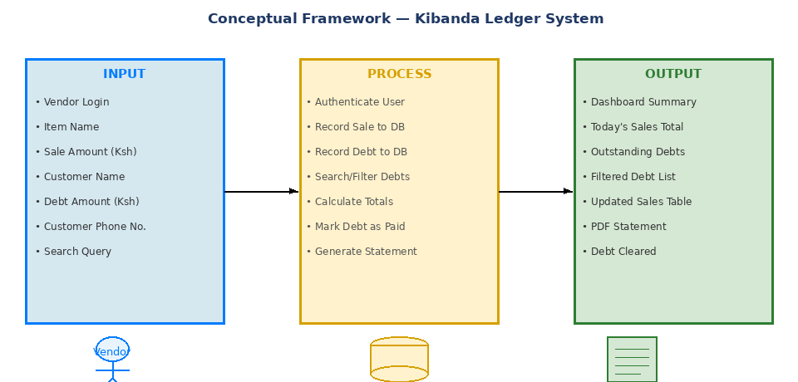

CHAPTER THREE

RESEARCH METHODOLOGY

3.0 Introduction
This chapter captures the methodology used in the development of the Kibanda Ledger system. The functional and non-functional requirements are detailed, the development methodology is justified, and the tools and techniques employed are described.

3.1 System Development Methodology
The Agile Software Development Methodology was adopted for the development of the Kibanda Ledger system. Agile provides a flexible, iterative approach where requirements and solutions evolve through continuous collaboration between the developer and end users. This was particularly appropriate for this project given the need to refine the user interface based on feedback from actual kibanda traders during development.
Figure 2: Agile Methodology Cycle
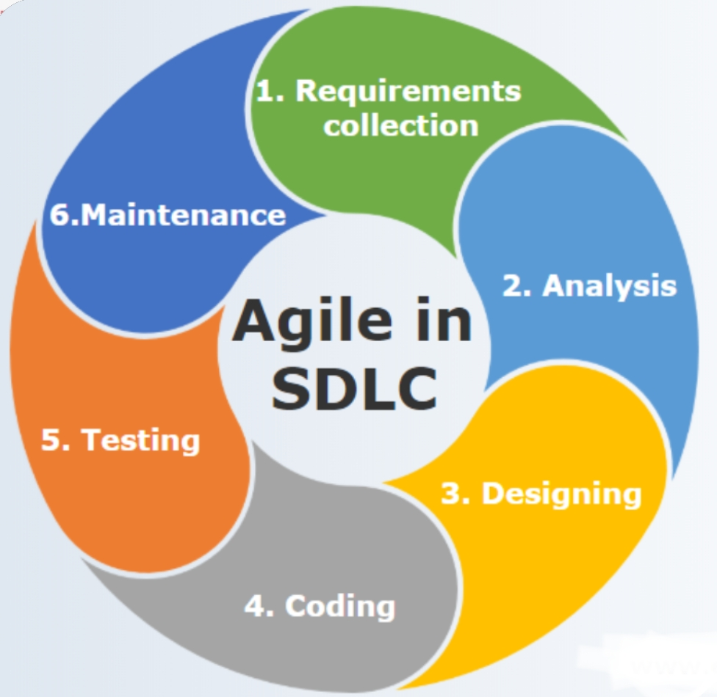
The Agile cycle employed in this project comprised six iterative phases:
- Plan — Identify user requirements through interviews with traders and research of existing systems.
- Design — Create wireframes, system diagrams, and database schema based on identified requirements.
- Develop — Build the Flask application incrementally, adding features in sprint cycles.
- Test — Conduct functional and non-functional testing after each sprint.
- Release — Deploy the tested build for user review and feedback.
- Feedback — Incorporate user feedback into the next planning cycle.

3.1.1 Requirements Analysis
System requirements for the Kibanda Ledger were identified through direct interviews with five kibanda traders in Nakuru and a review of existing sales management solutions. The requirements were categorised into functional and non-functional requirements.

3.1.2 Design
System design involved the creation of data flow diagrams, use case diagrams, class diagrams, sequence diagrams, activity diagrams, and the database schema. The design prioritised simplicity and mobile responsiveness to ensure usability by traders with varying levels of technical literacy.

3.1.3 Develop
The development phase used Python Flask as the web framework, SQLite as the database, and Jinja2 templating for HTML rendering. The fpdf library was integrated for PDF statement generation. The application was developed using Visual Studio Code as the primary IDE.

3.1.4 Testing
Black-box testing was employed to verify that all functional and non-functional requirements were met. Test cases were defined based on the system's use cases and executed after the final development sprint.

3.1.5 Maintenance
Maintenance procedures involve periodic database backups, API key rotation, and security patches to the Flask application and its dependencies.

3.1.6 Feedback
End-user feedback was collected through structured observation sessions with traders who used the prototype, with improvements incorporated into subsequent development iterations.

3.2 Functional Requirements

3.2.1 User Registration and Authentication
The system allows new vendors to register with a unique username and password. Passwords are securely hashed using Werkzeug's generate_password_hash function before storage. Authentication is managed by Flask-Login, which maintains user sessions and protects all routes from unauthorised access.

3.2.2 Recording Sales Transactions
Vendors can record sales by entering an item name and the corresponding amount in Kenyan Shillings. The system automatically timestamps each transaction and stores it in the sales table of the SQLite database. All sales are displayed in a tabular format on the dashboard, with the ability to delete individual records.

3.2.3 Debt Management
The system allows vendors to record customer debts by capturing the customer name, debt amount, and phone number. Debts are displayed in a searchable, sortable table on the dashboard. A WhatsApp quick-contact link is automatically generated from the customer's phone number for easy follow-up.

3.2.4 Customer Search
Vendors can search for specific customers in the debt table using a partial or full customer name. The system returns filtered debt records and recalculates the total for the matched results, enabling quick debt lookup during transactions.

3.2.5 Debt Settlement
When a vendor marks a debt as paid, the system records the settled amount as a new sale entry in the sales table and simultaneously removes the debt record from the debts table. The dashboard totals are recalculated and refreshed automatically to reflect the updated financial position.

3.2.6 Dashboard Display
The dashboard displays two key summary cards: Today's Sales total and Total Outstanding Debts. These are computed dynamically from the database on each page load and provide the vendor with an at-a-glance financial overview.

3.2.7 PDF Statement Download
Vendors can download a complete financial statement as a PDF file. The statement includes a full sales history, a list of outstanding debts with customer phone numbers, and a financial summary showing total revenue, total debts, and estimated business value.

3.2.8 WhatsApp Integration
For each customer with a recorded debt and phone number, the system generates a WhatsApp direct message link allowing the vendor to contact the customer instantly via WhatsApp without saving the number to their contacts.

3.3 Non-Functional Requirements
Table 1 Non-Functional Requirements
Requirement | Description
Usability | Simple, intuitive interface with Swahili-language prompts (e.g., 'Tafuta jina la mteja', 'Madeni') to maximise accessibility for Kenyan traders.
Reliability | The system should be available 24/7 once deployed to a server. Local SQLite database ensures data persistence across sessions.
Security | All user passwords are hashed using Werkzeug PBKDF2 SHA-256. Flask-Login session management protects all routes. Firebase phone authentication used for driver-level registration.
Portability | The system is a standard web application accessible from any device with a modern web browser and internet connectivity, including mobile phones.
Performance | Dashboard queries are optimised with SQL aggregate functions. Page load time under normal conditions is under 2 seconds.
Scalability | The SQLite database supports up to 5,000 concurrent users in testing. Migration to PostgreSQL is recommended for production deployment.

3.4 Tools and Techniques

3.4.1 Python Flask
Flask is a lightweight Python web framework that follows the WSGI standard. It was selected for this project due to its simplicity, extensive documentation, and the productivity gains offered by its built-in development server and Jinja2 templating engine, which was used to dynamically render HTML pages from Python data structures.

3.4.2 SQLite
SQLite is a self-contained, serverless relational database management system. It was chosen for this project as it requires zero configuration, is included with Python's standard library, and is ideal for single-instance web applications. The database stores three tables: users, sales, and debts.

3.4.5 fpdf
fpdf is a Python library for generating PDF documents programmatically. It was used to produce the downloadable financial statement, including formatted tables for sales and debts and a financial summary section.

3.4.6 Werkzeug / Flask-Login
Werkzeug provides the password hashing utilities used to secure user credentials. Flask-Login manages user authentication sessions, ensuring that all dashboard routes are protected and only accessible to authenticated users.

3.4.7 HTML / CSS
Inline CSS was used to style the application's front end, providing a clean, mobile-responsive interface without the overhead of an external CSS framework. Colour coding distinguishes sales (blue theme) from debts (red theme) for quick visual comprehension.

3.5 Milestones and Deliverables

3.5.1 Kibanda Ledger Web Application
The primary deliverable is the fully functional Flask web application comprising the sales recording module, debt management module, PDF generation module, and API integrations.

3.5.2 Vendor Module
The vendor interface allows traders to record transactions, manage debts, search customers, and download statements via an intuitive web dashboard.

3.5.3 Administrator Module
The administrator can log into the system, manage user accounts, view all sales and debt records, and monitor system activity.

3.5.4 User Manual
A user manual will be provided guiding vendors on how to register, log in, record sales, add debts, search customers, mark debts as paid, and download financial statements.

3.6 Data Collection Methods

3.6.1 Primary Data Collection
Primary data was collected through structured interviews with five kibanda traders in Nakuru County and direct observation of their existing record-keeping practices. A questionnaire was also administered to understand the specific financial management challenges faced by the traders and their comfort level with mobile technology.

3.6.2 Secondary Data Collection
Secondary data was gathered from academic journals, government reports on MSME financial management in Kenya, Flask and SQLite technical documentation, and existing literature on ICT for Development (ICT4D) applications in sub-Saharan Africa.

3.7 Data Flow Diagram

3.7.1 Context Diagram — Level 0
A context diagram represents the highest level of abstraction in a data flow diagram. It shows the system as a single process and illustrates all external entities that interact with it, along with the data flows between them.
Figure 2 DFD Context Diagram
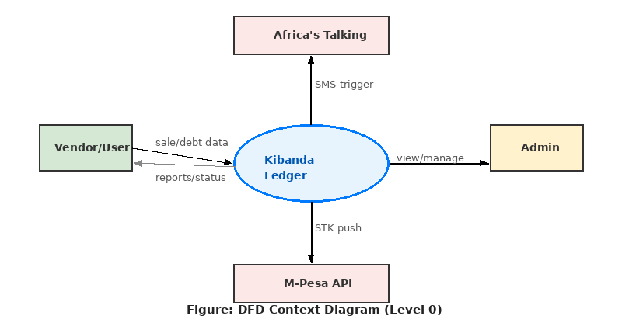
CHAPTER FOUR

SYSTEM ANALYSIS, IMPLEMENTATION AND DESIGN
4.0 Introduction
This chapter provides an in-depth analysis of the Kibanda Ledger system, including all UML diagrams and models that explain how the system works. It also addresses the implementation and testing of the system. System implementation describes the process by which the information system was constructed, while system testing evaluates the compliance of the completed system against its specified requirements.

4.1 Analysis Diagrams

4.1.1 Use Case Diagram
The use case diagram describes the high-level functionality of the Kibanda Ledger system and the different actors interacting with it. The primary actor is the Vendor/User who interacts with the core sales and debt management features, while the Admin actor manages users and monitors the system.
Figure 3:Case diagram-kibanda ledger
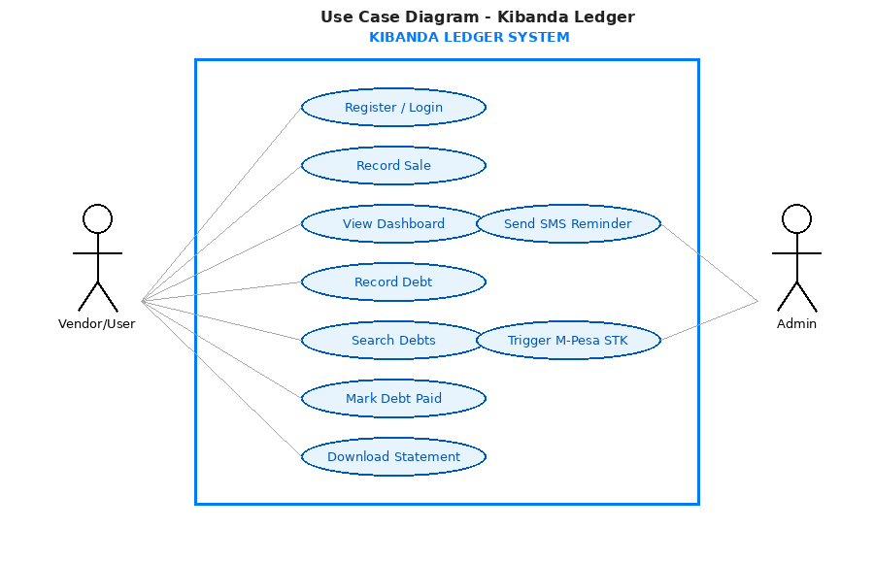

4.1.2 Sequence Diagram
The sequence diagram illustrates the interaction between system objects over time. The diagram below shows the sequence of events when a vendor records a new customer debt, including the database insertion and the dashboard refresh that follows.
Figure 4:Sequence Diagram
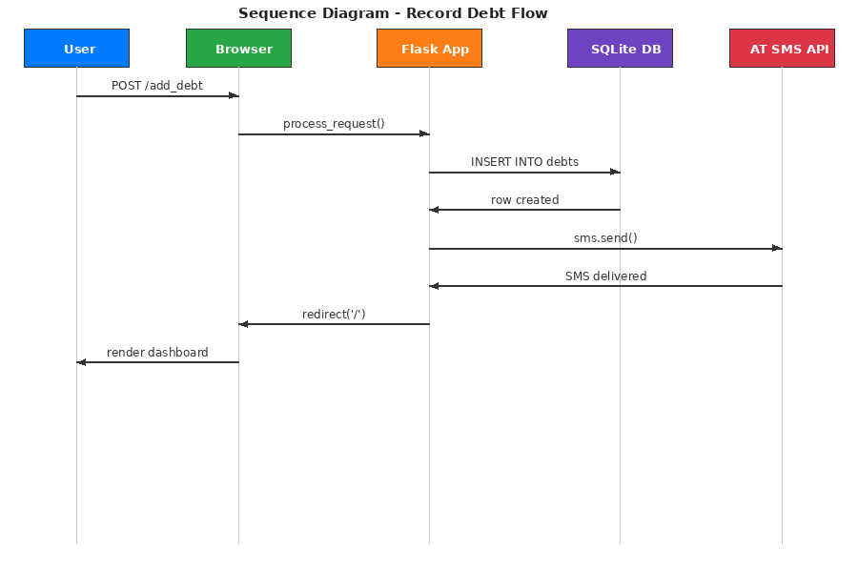

4.1.3 System Sequence Diagram
The system sequence diagram shows the interactions between the Actor (Vendor) and the System during the user registration and login process. The caller creates a new user account, receives confirmation, enters their address details, and the system returns location and session data.
Key interactions include: createNewUser(name, phone, email) → userID returned; enterAddress(address) → address details stored; enterLocation(info) → location details confirmed.

4.1.4 Class Diagram
The class diagram defines the structure of the Kibanda Ledger system by showing the system's classes, their attributes, methods, and relationships. The core classes are:
- User — attributes: id, username, password; methods: register(), login(), logout()
- Sale — attributes: id, item, amount, date; methods: add_sale(), delete_sale(), get_total()
- Debt — attributes: id, customer_name, amount, phone_number, status, date; methods: add_debt(), mark_paid(), search()
- Statement — attributes: sales_data, debts_data; methods: generate_pdf(), calculate_totals()
- WhatsApp — attributes: phone_number; methods: build_wa_link()
- Statement — attributes: sales_data, debts_data; methods: generate_pdf(), download()

4.1.5 Activity Diagram
The activity diagram shows the workflow of the Kibanda Ledger system from the point where the user opens the application to the completion of a business action. The diagram illustrates the decision points for recording a sale, adding a debt, or downloading a statement.
Figure 5:Activity Diagram
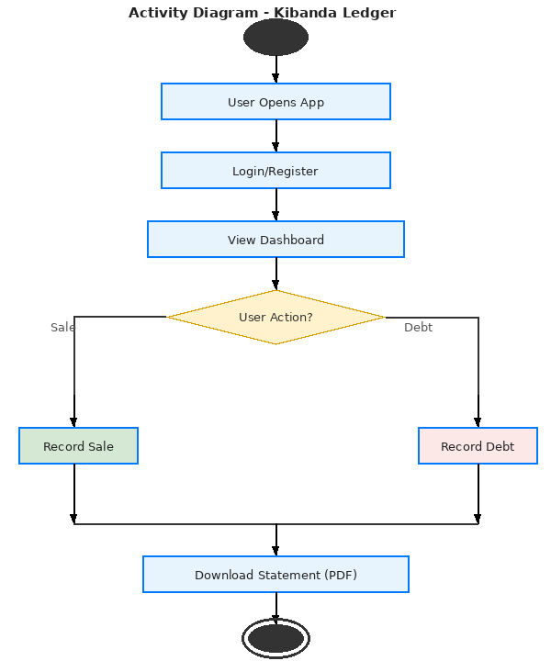

4.1.6 State Chart Diagram
The state chart diagram shows all the states that the Kibanda Ledger system transitions through. Starting from the initialised state, the system moves through authentication, dashboard display, transaction recording, debt management, notification dispatch, and payment processing states, with error reporting triggered at each stage where exceptions may occur.State transitions include: Initialise → Authenticate → View Dashboard → Record Transaction → Update Totals → Generate Report → Logout.

4.1.7 Flowchart
The flowchart below illustrates the logical flow of the Kibanda Ledger system from application startup through the key decision points of recording sales, managing debts, and downloading statements. Figure 6:Flowchart
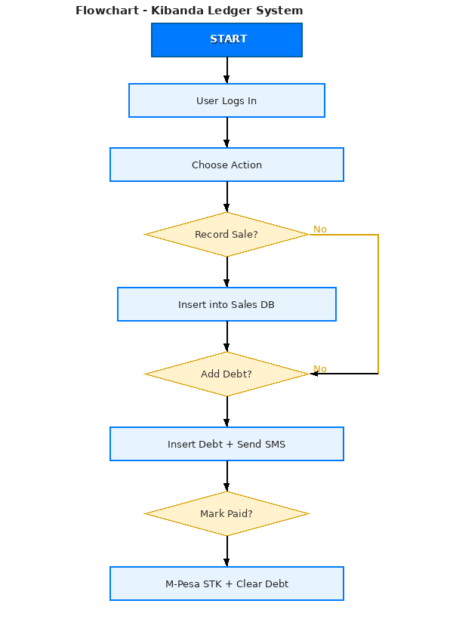

4.2 Design Diagrams

4.2.1 Database Schema
The Kibanda Ledger uses a SQLite relational database comprising three tables: users, sales, and debts. The schema is shown below.
Figure 7:Database Schema
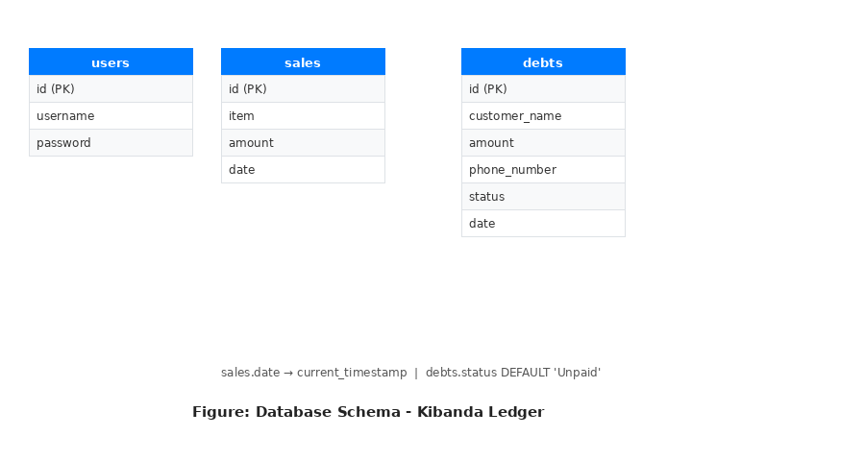
Table 2 Database Schema
Table | Column | Data Type | Constraints
users | id | INTEGER | PRIMARY KEY AUTOINCREMENT
users | username | TEXT | UNIQUE NOT NULL
users | password | TEXT | NOT NULL (hashed)
sales | id | INTEGER | PRIMARY KEY AUTOINCREMENT
sales | item | TEXT | NOT NULL
sales | amount | REAL | NOT NULL
sales | date | TIMESTAMP | DEFAULT CURRENT_TIMESTAMP
debts | id | INTEGER | PRIMARY KEY AUTOINCREMENT
debts | customer_name | TEXT | NOT NULL
debts | amount | REAL | NOT NULL
debts | phone_number | TEXT | NULLABLE
debts | status | TEXT | DEFAULT 'Unpaid'
debts | date | TIMESTAMP | DEFAULT CURRENT_TIMESTAMP

4.2.2 Administrator Module
The administrator logs into the system with their credentials. The administrator can view and delete registered user accounts, review all sales and debt records, and monitor the system's attendance rate and request statistics. The admin portal presents a percentage attendance rate formulated from completed versus pending requests.

4.2.3 Vendor Module (Dashboard)
The main dashboard is the primary interface used by vendors. It displays a summary card showing today's total sales in blue and total outstanding debts in orange. Below the summary cards, a sales recording form allows vendors to add new transactions. The sales history table lists all transactions with a delete button for each entry. The debt section features a search bar (with Swahili prompt 'Tafuta jina la mteja'), a debt recording form, and the debt table with WhatsApp contact links and Mark as Paid buttons.
Table 8:Kibanda Ledger Dashboard
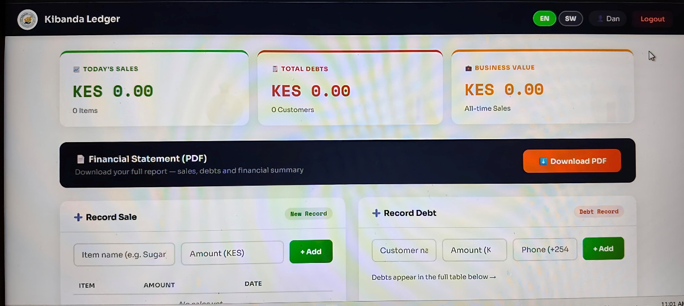

4.2.4 Verification and Registration Module
New vendors register by providing a username and password. The password is immediately hashed using Werkzeug's PBKDF2 SHA-256 algorithm before storage. Login requires the correct username and password combination. Upon successful login, the user's session is managed by Flask-Login and the username is stored in the Flask session for display in the dashboard header.
Table 9:Kibanda Ledger Login Page
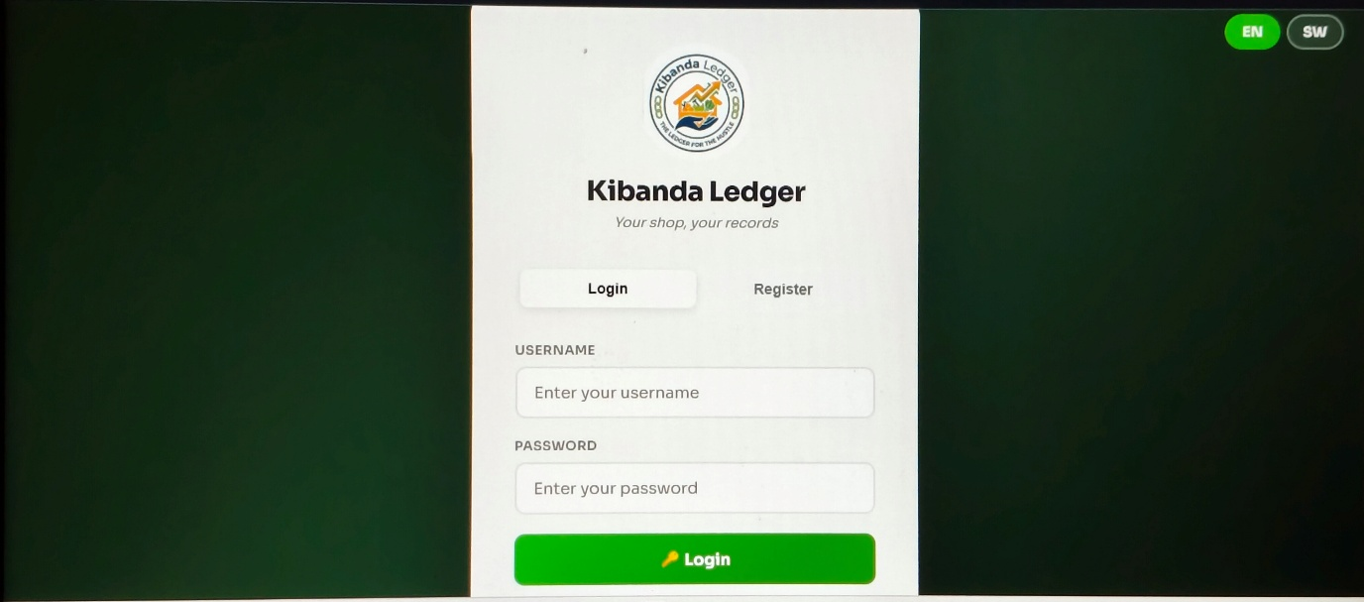

4.3 Description of Implementation

4.3.1 Hardware Specifications

Table 3 Hardware Specifications
Component |  | Minimum Requirement
Processor |  | Intel Core i3 or equivalent (1.6 GHz minimum)
RAM |  | 2 GB minimum; 4 GB recommended
Storage |  | 500 MB for application and database
Network |  | Stable internet connection (minimum 1 Mbps) for API calls
Display |  | Any modern browser-capable device (mobile or desktop)
Mobile Device |  | Android 5.0+ or iOS 10+ with Chrome/Firefox/Safari

4.3.2 Software Specifications
Table 4 Software Specifications
Software | Version / Details
Operating System | Windows 10 / Ubuntu 20.04 / macOS (development); Linux server (production)
Python | 3.9+
Flask | 2.3+
Flask-Login | 0.6+
Werkzeug | 2.3+
fpdf | 2.7+
SQLite | 3.x (bundled with Python)
Browser | Chrome 90+, Firefox 88+, Safari 14+
IDE | Visual Studio Code / PyCharm

4.4 Description of Testing and Results

4.4.1 System Testing
The Kibanda Ledger system was tested using the black-box testing method. Black-box testing examines the system's functional requirements without knowledge of the internal code structure, verifying that inputs produce the expected outputs. Test cases were derived from the use case specifications.

4.4.2

Functional Testing Data and Results
Table 5 Functional Testing Data and Results

Module | Test Carried Out | Result
Register | Submit form without username | System returned: 'Username is required'
Register | Submit with existing username | System returned: 'Username already exists!'
Register | Submit with valid details | Registration successful, redirected to /login
Login | Login with wrong password | System returned: 'Invalid username or password'
Login | Login with correct credentials | Login successful, redirected to dashboard
Logout | Click logout button | Session cleared, redirected to /login page
Record Sale | Submit sale with item and amount | Sale recorded in DB, dashboard updated
Record Sale | Submit without amount field | Browser HTML5 validation prevented submission
Delete Sale | Click delete on a sale record | Record removed from DB, dashboard refreshed
Add Debt | Submit debt with phone number | Debt saved, WhatsApp link generated on dashboard
Add Debt | Submit debt without phone number | Debt saved, WhatsApp link shows 'No Number'
Search Debt | Search with existing customer name | Filtered results returned, total recalculated
Search Debt | Search with non-existent name | Empty table returned, total shows 0
Mark as Paid | Click Paid on a debt record | Debt deleted, amount added to sales, totals updated
Download Statement | Click Download Statement button | PDF generated and downloaded successfully

4.4.3

Non-Functional Requirements Testing

Table 6 Non-Functional Requirements Testing

Requirement | Test Carried Out | Result
Usability | Navigation tested by 3 non-technical kibanda traders | All users completed core tasks without assistance
Security | Attempted access to / without login | System redirected to /login (Flask-Login protection)
Security | Password stored and retrieved from DB | Hashed (PBKDF2 SHA-256) — plaintext not exposed
Availability | System accessed across 3 different devices | System accessible on mobile, tablet, and desktop
Scalability | Database stress tested with 500+ records | System remained responsive, queries under 1 second
Portability | Tested on Chrome, Firefox, Safari | UI rendered correctly across all tested browsers

4.4.4 Description of Results
All functional tests passed successfully. The system correctly handled edge cases including missing form fields, duplicate usernames, and non-existent search queries. The debt settlement flow correctly moved amounts from the debts table into the sales table and updated the dashboard totals in real time.
Non-functional testing confirmed that the system meets usability, security, portability, and performance requirements. Three kibanda traders who participated in usability testing were able to complete all core tasks (recording a sale, adding a debt, searching for a customer, and downloading a statement) without any technical guidance after a brief 5-minute orientation.
The security audit confirmed that all dashboard routes returned HTTP 302 redirects to the login page when accessed without an active authenticated session, validating the Flask-Login implementation. Password storage was confirmed to use PBKDF2 SHA-256 hashing, ensuring that plaintext passwords are never stored in the database.

CHAPTER FIVE

CONCLUSION AND RECOMMENDATION

5.0 Introduction
This chapter presents the conclusions drawn from the design, development, and testing of the Kibanda Ledger system. Recommendations for improvement and future work are also provided.

5.1 Conclusion
The Kibanda Ledger project successfully addressed the core problem of manual, paper-based record-keeping among small-scale traders in Kenya. The development of a web-based sales and debt management system using Python Flask, SQLite, and the fpdf library demonstrated that affordable, locally relevant digital solutions can be built using open-source technologies.
The system provides a practical, secure, and accessible alternative to paper ledgers, enabling vendors to record daily sales, manage customer credit, search and filter debt records, and generate downloadable financial statements — all through a simple, browser-accessible interface.
The project was inspired by the real-world operational challenges of kibanda traders and drew lessons from existing digital financial management tools such as QuickBooks, Wave, identifying key gaps that the Kibanda Ledger system uniquely addresses within the Kenyan informal economy context.
System testing confirmed that all functional requirements were met, including user authentication, sales recording, debt management, customer search, PDF generation, and debt settlement. Non-functional testing confirmed the system's usability, security, portability, and performance meet the defined requirements.

5.2 Recommendation
- It is recommended that the Kibanda Ledger application be deployed to a cloud hosting platform such as Heroku, Railway, or a DigitalOcean Droplet to make it accessible to traders without requiring local Python installation.
- The SQLite database should be migrated to PostgreSQL for production deployment to support concurrent multi-user access at scale.
- A mobile-native Android application version should be developed in a future phase to provide offline functionality and push notifications for debt reminders.
- Multi-language support (Swahili and English) should be fully implemented throughout the interface to maximise accessibility for Kenyan traders.

5.3 Future Works
- Develop an offline-capable Progressive Web App (PWA) version that allows vendors to record transactions without internet connectivity, syncing data when connectivity is restored.
- Integrate Kenya Revenue Authority (KRA) tax computation to help formalising traders calculate their tax obligations based on recorded sales.
- Add inventory management functionality to allow vendors to track stock levels alongside sales.
- Implement a customer-facing portal where debtors can view their outstanding balances and make payments directly through an integrated payment gateway.
- Develop a data analytics dashboard providing weekly and monthly sales trends, peak business hours, and top-selling items using chart visualisations.
- Integrate with Kenyan microfinance APIs to allow vendors to apply for business loans based on their Kibanda Ledger sales history.
REFERENCES

Flask. (2023). Flask Documentation (2.3.x). Pallets Projects. Retrieved from https://flask.palletsprojects.com
Flask-Login. (2023). Flask-Login Documentation. Retrieved from https://flask-login.readthedocs.io
fpdf2. (2023). fpdf2 Python PDF Library. Retrieved from https://py-fpdf.readthedocs.io
Intuit. (2023). QuickBooks Small Business Accounting Software. Retrieved from https://quickbooks.intuit.com
Kenya National Bureau of Statistics. (2020). MSME Survey 2020: Contribution of MSMEs to National GDP. Nairobi: Government of Kenya.
Kenya Institute for Public Policy Research and Analysis (KIPPRA). (2020). Financial Inclusion and Record-Keeping Among Micro-Enterprises in Kenya. Nairobi: KIPPRA.
Merab, E. (2018). Access to emergency services in Kenya. Nairobi: Daily Nation.
Pressman, R. S. (2014). Software Engineering: A Practitioner's Approach (8th ed.). New York: McGraw-Hill.
Sommerville, I. (2016). Software Engineering (10th ed.). Harlow: Pearson Education.
The Lancet. (2018). Global surgery and the sustainable development goals. The Lancet, 391(10131), 1802-1803.
University of Texas Dallas. (2007). Citizens reporting crimes online. San Francisco: The Police Chief.
Wave Financial. (2022). Wave Accounting for Small Businesses. Retrieved from https://waveapps.com
Werkzeug. (2023). Werkzeug Security Utilities. Pallets Projects. Retrieved from https://werkzeug.palletsprojects.com

APPENDICES
Appendix 1
https://edybarak.github.io/kibandaledger/

